BRAILLE BASED IoT HOME AUTOMATION — DETAILED STRUCTURED NOTES
1. PROJECT OVERVIEW
The project "Braille Based IoT Home Automation" is designed to assist visually impaired individuals in controlling home appliances using Braille input, haptic (vibration) feedback, and audio feedback. The system ensures both accessibility and safety by integrating emergency features and remote monitoring via IoT.
The system consists of two main modules:
- Remote Module — used by the user for Braille input and command transmission.
- Appliance Control Module — used for executing commands to control appliances, monitor safety, and send emergency alerts.
2. SYSTEM MODULES
2.1 Remote Module
This module acts as the user interface for the visually impaired person. It allows input through a Braille keypad and provides vibration (haptic) and audio (buzzer) feedback.
2.2 Appliance Control Module
This module controls all connected home appliances (lights, fans, and door lock) and manages safety alerts (like fire detection). It communicates with the remote module using Wi-Fi (TCP protocol) and sends emergency notifications via Blynk.
3. REMOTE MODULE — COMPONENTS AND FUNCTIONS
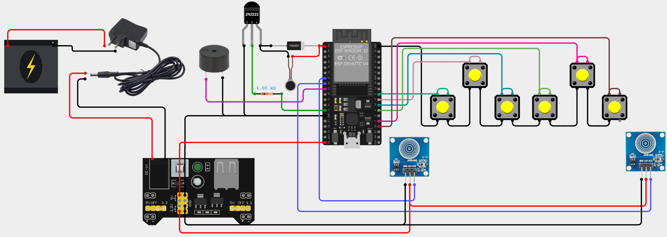
3.1 TTP223 Touch Sensors
- Quantity: 2 sensors
- Function:
- In the remote module, while the Braille pushbuttons are in the pressed condition, the touch sensors are checked to distinguish between alphabet and number inputs, especially for characters in the ranges A–J and 1–0, which share the same Braille patterns.
- In the remote module, while the Braille pushbuttons are pressed, activation of the left touch sensor indicates that the entered Braille character is a number (1–0 range).
- In the remote module, while the Braille pushbuttons are pressed, activation of the right touch sensor indicates that the entered Braille character is an alphabet (A–J range).
- In the remote module, a short simultaneous touch on both touch sensors is used to confirm the typed command and permit transmission of the command.
- In the remote module, a long simultaneous touch on both touch sensors is used to trigger an emergency condition.
- In the remote module, upon an emergency trigger, the touch sensors initiate the remote module to send an emergency command to the appliance control module for Blynk notification.
- In the remote module, the emergency condition is indicated to the user through continues vibrations along with short beeps.

3.2 Vibration Motors (Haptic Feedback)
- Quantity: 4 motors
- Driver: NPN transistor-based circuit
  - 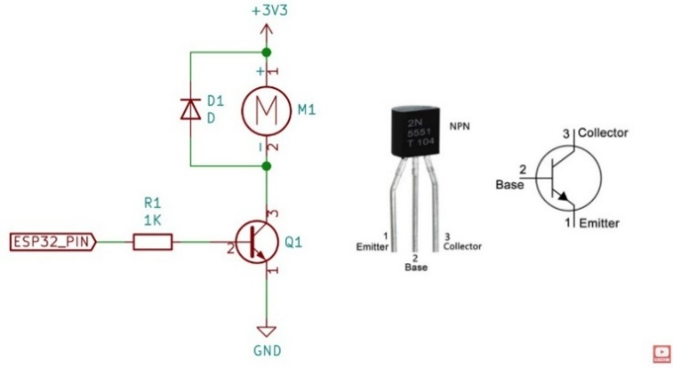
  - Transistor – 2N2222.
  - Diode – 1N4007.
  - Resistor – 1kΩ.
- Function: Provide vibration feedback based on user actions.
Feedback Type | Description | Meaning
Ts | One short vibration | Command sent and executed
Tts | Continues short vibrations | Emergency trigger (if not sensed in 15s, vibrations pass sequentially from one motor to another)
Tl | One long vibration | Invalid command
T5s | Five short vibrations | Someone entered correct password
T5l | Five long vibrations | Someone entered wrong password
3.3 Buzzers (Auditory Feedback)
- Quantity: 2 buzzers.
- Functions:
  - Short beep (Ts): Command sent or Command executed.
  - Continues short beeps (Tts): Emergency trigger.
  - Long beep (Tl): Invalid command.
  - 5 short beeps: correct password .
  - 5 long beeps: incorrect password.
3.4 Braille Keypad (6 Pushbuttons)
- Quantity: 6 pushbuttons in INPUT_PULLUP mode
- Layout: Two rows resembling a Braille cell.
  - Left Hand Row: Buttons 1, 2, 3 (left to right)
  - Right Hand Row: Buttons 4, 5, 6 (left to right)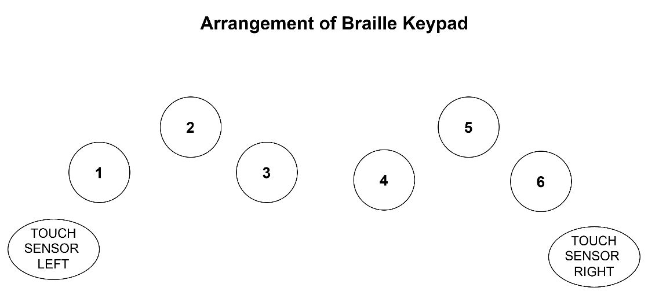

- Function: Each button represents one of the six Braille dots, used to input Braille characters that are then converted into text commands.
  - 3.4.1 The Alphabet (A–Z):
Character | Dot Mapping  ( pressed Buttons) | Pattern Logic
A | 1 | Base pattern
B | 1, 2 | Base pattern
C | 1, 4 | Base pattern
D | 1, 4, 5 | Base pattern
E | 1, 5 | Base pattern
F | 1, 2, 4 | Base pattern
G | 1, 2, 4, 5 | Base pattern
H | 1, 2, 5 | Base pattern
I | 2, 4 | Base pattern
J | 2, 4, 5 | Base pattern
K | 1, 3 | Adds dot 3 to A
L | 1, 2, 3 | Adds dot 3 to B
M | 1, 3, 4 | Adds dot 3 to C
N | 1, 3, 4, 5 | Adds dot 3 to D
O | 1, 3, 5 | Adds dot 3 to E
P | 1, 2, 3, 4 | Adds dot 3 to F
Q | 1, 2, 3, 4, 5 | Adds dot 3 to G
R | 1, 2, 3, 5 | Adds dot 3 to H
S | 2, 3, 4 | Adds dot 3 to I
T | 2, 3, 4, 5 | Adds dot 3 to J
U | 1, 3, 6 | Adds dot 6 to K
V | 1, 2, 3, 6 | Adds dot 6 to L
W | 2, 4, 5, 6 | Irregular pattern (historical exception)
X | 1, 3, 4, 6 | Adds dot 6 to M
Y | 1, 3, 4, 5, 6 | Adds dot 6 to N
Z | 1, 3, 5, 6 | Adds dot 6 to O
  - 3.4.2 The Number (1-9&0)
Number | Corresponds to Letter | Dot Mapping (Button Sequence)
1 | A | 1
2 | B | 1, 2
3 | C | 1, 4
4 | D | 1, 4, 5
5 | E | 1, 5
6 | F | 1, 2, 4
7 | G | 1, 2, 4, 5
8 | H | 1, 2, 5
9 | I | 2, 4
0 | J | 2, 4, 5

3.5 ESP32-WROOM-32 (Remote Controller)
- Role: Central controller for the remote module.
- Functions:
  - Converts Braille inputs into text commands.
  - Sends commands to the Appliance Control Module via Wi-Fi using TCP protocol.
  - Provides feedback using buzzers and vibration motors.
  - Detects emergency inputs from touch sensors.
Supported typed Commands:
- L1 — toggles the light in Room 1.
- L2 — toggles the light in Room 2.
- Fxy — controls fan speed (x = room number (1,2) , y = speed 0–4).
- All1– to on all devices (fans to speed 4).
- All0 – to off all devices.
- OPN – to open the door to reduce complexity doors closes automatically.
4. APPLIANCE CONTROL MODULE — COMPONENTS AND FUNCTIONS
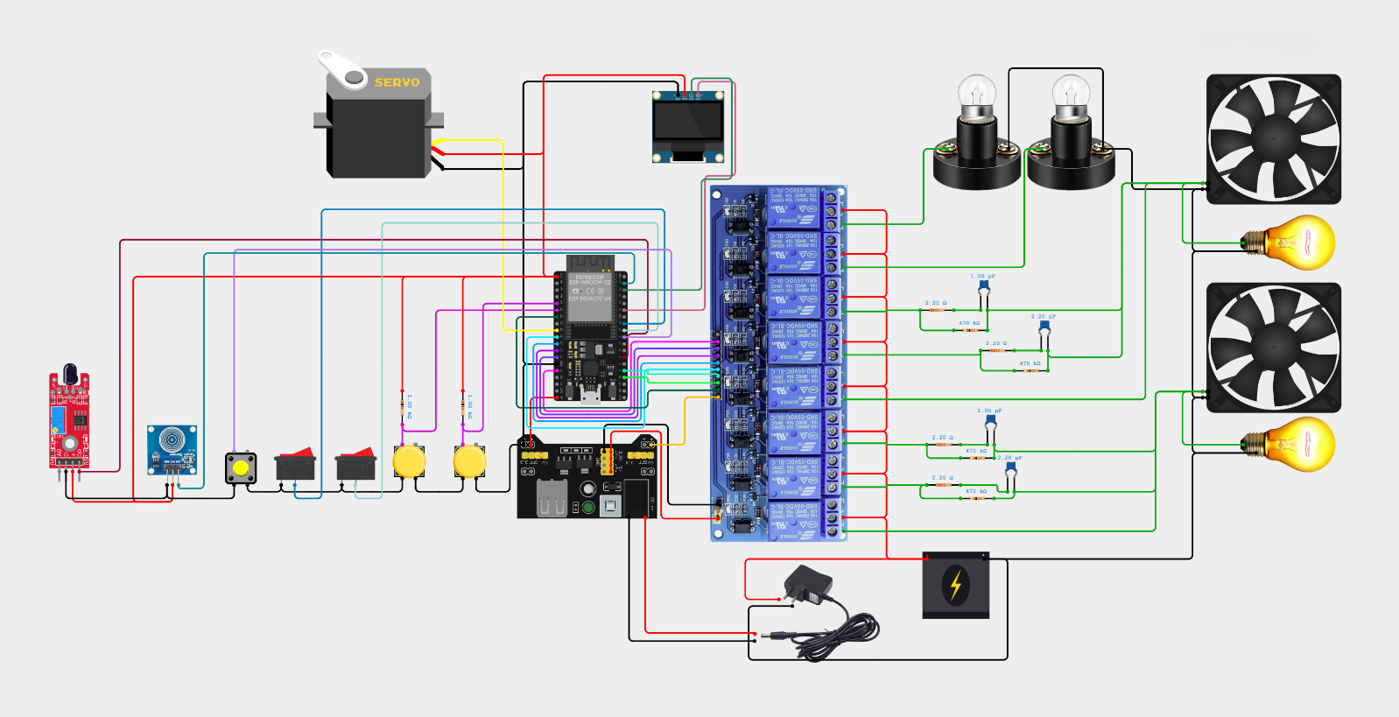
4.1 ESP32-WROOM-32 (Controller)
- Acts as the central control hub for all appliances.
- Receives TCP commands from the remote module.
- Validates commands and sends appropriate feedback signals back to the remote controller.
- Controls relays for appliance switching.
- Detects fire via IR sensor and triggers emergency notification via Blynk after getting the user confirmation that he has sensed the emergency, which is read from the touch sensors.
4.2 OLED Display:
- First row: Displays the latest received command and its timestamp (scrolling).
- Second row: Displays the current status of all appliances (scrolling).
- Also displays “!ALERT!” during fire emergency.
- Displays password bits while typing password and show “access allowed” or “access denied” after submitting.
4.3 Fire Detection Circuit
- Sensor: IR flame sensor
- Function: Detects fire and sends alert feedback to remote module.
- Action: ESP32 sends an emergency feedbacks to the remote module after user confirmation from the touch sensors the remote module acknowledges the appliance control module to send emergency notification using Blynk.
4.4 Blynk integration:
- Function: displays the appliance status remotely .
  - 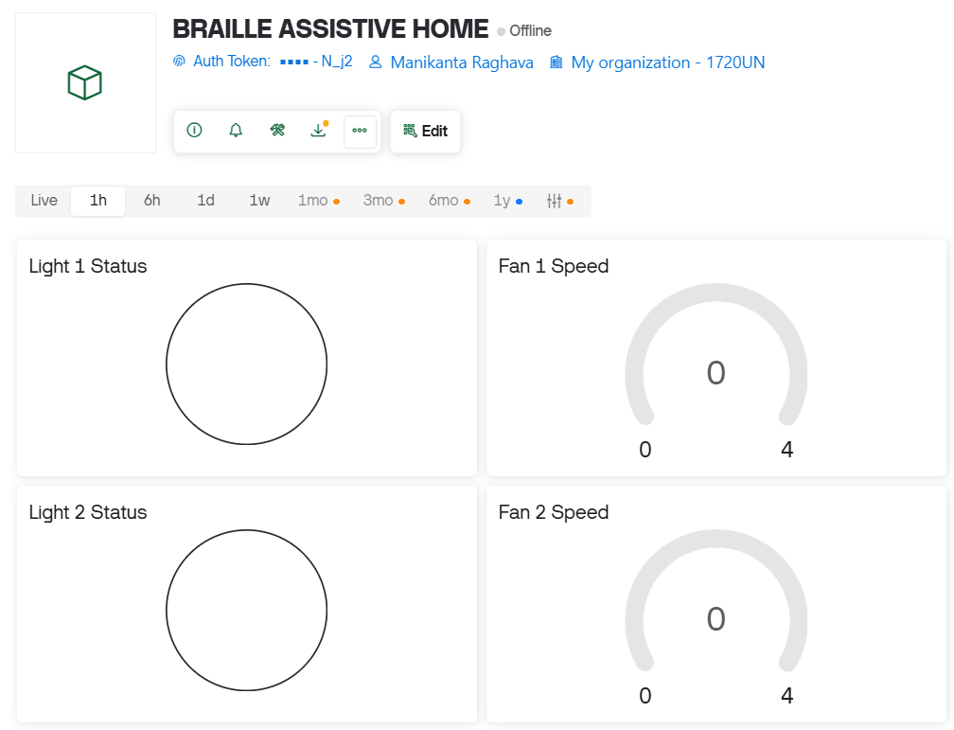
- ️notifies during emergency using push notification.
  - 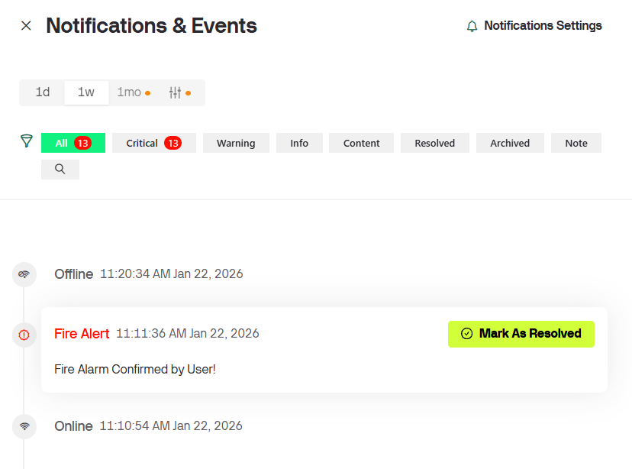
4.5 Password Circuit
- Components: Touch sensor + Pushbutton
- Function:
  - Button press + touch as logic '1'; No button press + touch as '0'.
  - A binary password (e.g., 1010) is entered using above method.
  - Single touch: selects bit.
  - Long on Touch sensor: confirms password submission.
  - For re-entry, long press on the push button is required.
4.6 Relays (for Appliance Control)
- Connected to Appliances:
  - Bulb
  - Fan (with speed control)
- All relays connected to the Normally Open (NO) terminal.
- 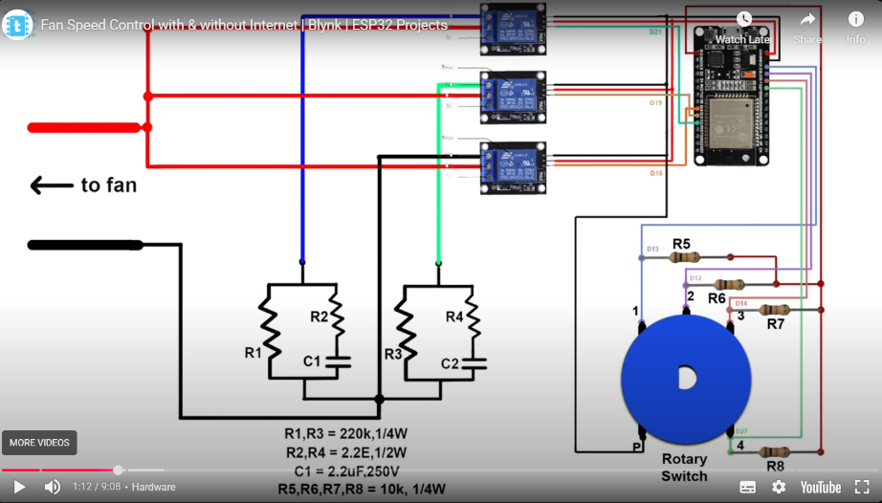
- 4.6.1 Fan Speed Regulation Circuit ↓
Speed Level | Active Relays | Capacitance (C_eff) | Description
0 (off) | No active relay | 0 | Off position.
1 (Low) | Relay 1 | 1.0 µF | Minimum speed, lowest current flow
2 (Low-Medium) | Relay 2 | 2.2 µF | Secondary branch two parallel capacitors increase current comparatively, medium low speed
3 (Medium-High) | Relays 1 & 2 | 3.2 µF | Parallel capacitors increase current, medium-high speed
4 (Maximum) | Relay 3 | Bypass | Direct AC voltage for full speed
Capacitor and Resistor Values:
- R1, R3 = 220 kΩ (¼ W)
- R2, R4 = 2.2 Ω ( 1W or 2W)
- C1 = 1.0 µF, 400V
- C2 = 2.2 µF,400V
5. FEEDBACK MECHANISM
Feedbacks patterns are discussed in 3.2 and 3.3.
Type | Component | Purpose
Haptic | 4 vibration motors | Tactile confirmation of command execution, emergency, and errors
Audio | 2 buzzers | Audible indication of actions and alerts
6. COMMUNICATION BETWEEN MODULES
- Two ESP32 boards connected as follows:
  - They connected to the same Wi-Fi if an active Wi-Fi router is available.
  - If router is not available the both esp32s connected to the each other by AP + STA mode.
- Communication(command transfer) is done through Wi-Fi using TCP protocol.
7. MANUAL MODE
- I used a smart button for manual control of fans which is functions as below
  - One click i.e. short press on the button toggles the fan state between ON/OFF
  - Long press >0.5s switches to next speed if it reaches to maximum speed it roll over to 1st speed.
  - 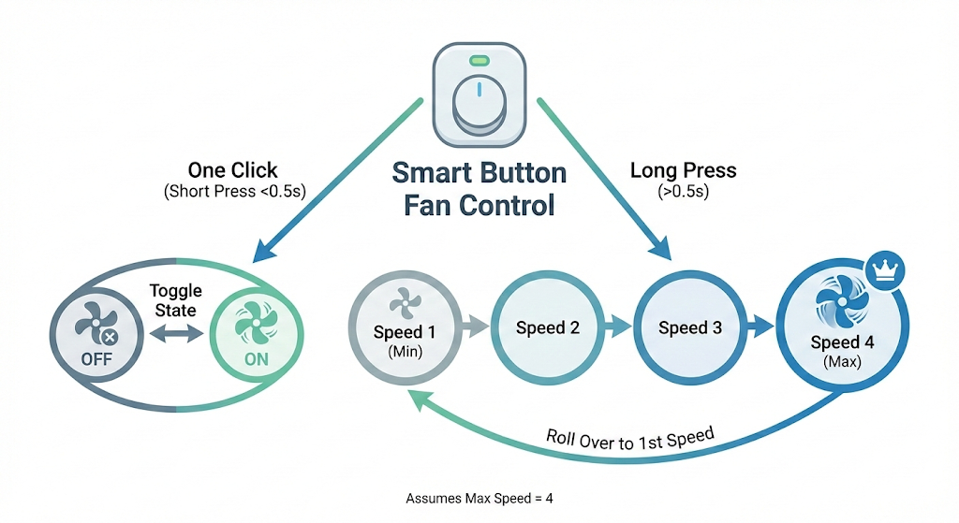
- Used input pullup switches for light control.
  - 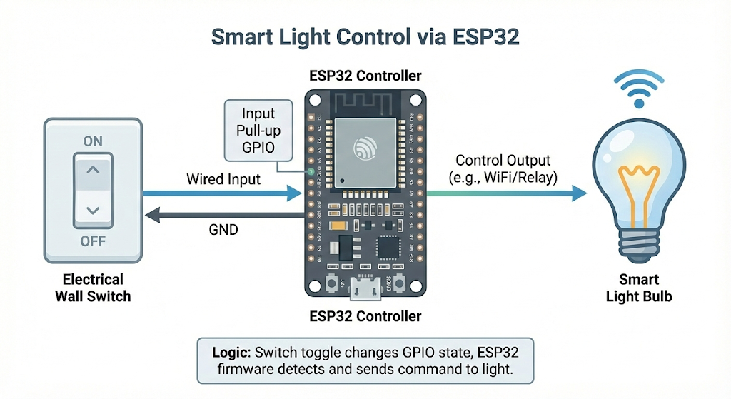
8. PROJECT OBJECTIVES
- Convert Braille input into text commands for appliance control.
- Ensure safe and accessible control through tactile (vibration) and audio (buzzer) feedback.
- Provide fire and emergency alerts via Blynk notification to caretaker after user confirmation.
- Enable IoT-based remote monitoring and control using Blynk app.
- Maintain reliable communication using TCP over Wi-Fi (router or AP+STA mode).
- Implement door lock access through password verification.
- Include manual fan speed and switch-based control for flexible operation.
9. SUMMARY
This system ensures full accessibility for visually impaired users, combining Braille-based input, IoT connectivity, emergency handling, manual control, and multi-feedback mechanisms for safety and usability.
Workflow of the project:
- Remote Module:
  - The user can enter the braille characters in the remote module using the pushbutton setup described in the Topic 3.4.The character entered using push button setup is distinguished between alphabet & number by using the touch sensors at the time of braille input, if the left touch sensor is got touch input the entered character is a number which added to the text command & if the right touch sensor get the touch input it is an alphabet which is also added to the text command.
    - The mapping of characters and numbers are described in topics 3.4.1 for alphabets and 3.4.2 for numbers, the typed command is confirmed to send by giving a simultaneous touch on the two touch sensors get the touch input for short time. If two touch sensors get the touch input for long time the remote send commands to send emergency notification using the Blynk in the appliance control module. The user identifies the emergency using the feedback - continues short vibrations Emergency trigger.
  - Secondary one is it gives multimode feedback to the user in the haptic and auditory modes as described as in topic 3.3,3.4 respectively.
    - The remote module has directly given the short beep & short vibration when command sent successfully, for remaining feed backs (i.e. command successfully executed, invalid command, emergency ,correct password & wrong password) it waits for the feedback signals form the appliance control module.
- The commands that are supported by the system is described in the Supported Commands under the topic 3.5.
  - You can place these commands in appliance control module.
- Appliance control Module:
  - Appliance control Module receives the command from the remote module and process them accordingly by activating the relays as described:
    - If command is in the form of below commands Appliance control Module and gives Command executed feedback to remote module. Else it gives invalid command feedback which are described 3.2 and 3.3.
      - Switch Light in Room X or LX — toggles the light in Room X.
        - X=Room number(1,2).
      - Fan x with speed y or Fxy — controls fan speed according to the
Speed Level | Active Relays | Capacitance (C_eff) | Description
0 (off) | No active relay | 0 | Off position.
1 (Low) | Relay 1 | 2.2 µF | Minimum speed, lowest current flow
2 (Low-Medium) | Relay 2 | 4.4 µF | Secondary branch two parallel capacitors increase current comparatively, medium low speed
3 (Medium-High) | Relays 1 & 2 | 6.6 µF | Parallel capacitors increase current, medium-high speed
4 (Maximum) | Relay 3 | Bypass | Direct AC voltage for full speed
      - x = room number (1,2) , y = speed 0–4.
  - Appliance control Module has a password circuit which works as described in the topic 4.5 it checks for the password 1001 and send the right password and wrong password feedback signals to the remote module.
    - If the user presses all keys on the braille keyboard remote send open the door command to Appliance control Module & Then Appliance control Module opens the door by making the servo motor to 90 degrees Other wise the servo is always 0 degree i.e. locked state.
  - Appliance control Module has a flame sensor to detect the fire, if fire is detected Appliance control Module send emergency feedback to the remote module then from remote module Appliance control Module get a acknowledge to form user when he/she gives the long touch on both touch sensors, then using that acknowledge the Appliance control Module sends emergency message to the caretaker with the help of Blynk.
  - Appliance control Module have 2 switches for the manual operation of lights and 2 potentiometers used to control the fans manually using info in topic 7.
  - The appliance status and last command is displayed in the OLED Display as 2nd and 1st rows respectively in scrolling manner.
  - The appliance status is also transfers to Blynk for remote monitoring. Make sure its only displaying the appliance status only not controlling.
- The Inter Connection:
  - There is to cases of connection between modules. They are,
    - Router available
      - The both esp32’s connected to the same Wi-Fi and inter transfer the commands. As internet is available the remote monitoring is possible through Blynk.
    - Router not available
      - As internet is not Available to make sure the system works for appliance accessing the both esp32’s interconnect using AP +STA mode(i.e. creating its own network).
  - After establishing the connection its time to communicate ,the both esp32’s must act as transmitter as well as the receiver also , I choose TCP based communication link between them.

